PROJECT REPORT

**INPUTS**

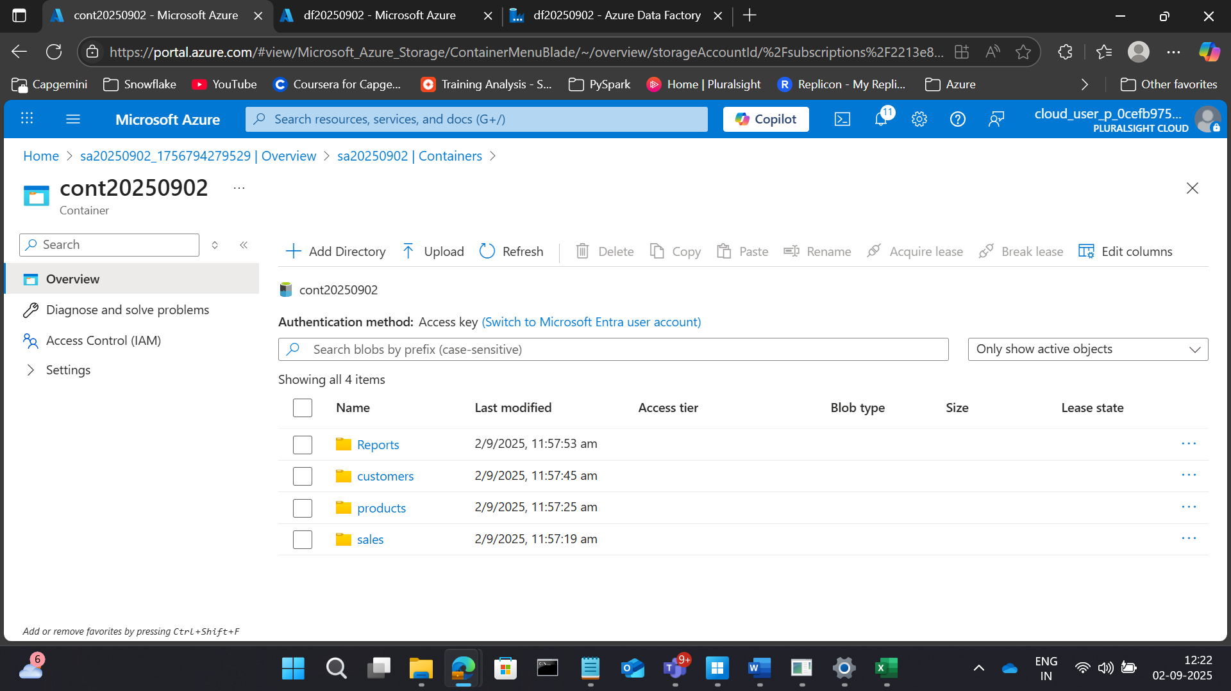



**1. Customer Purchase Summary**

**Goal:** Generate a report showing total purchases, total amount spent, and number of products bought per customer.

**Transformations:**

* Join sales.csv with customers.csv and products.csv.
* Group by customer_id.
* Aggregate quantity and price.

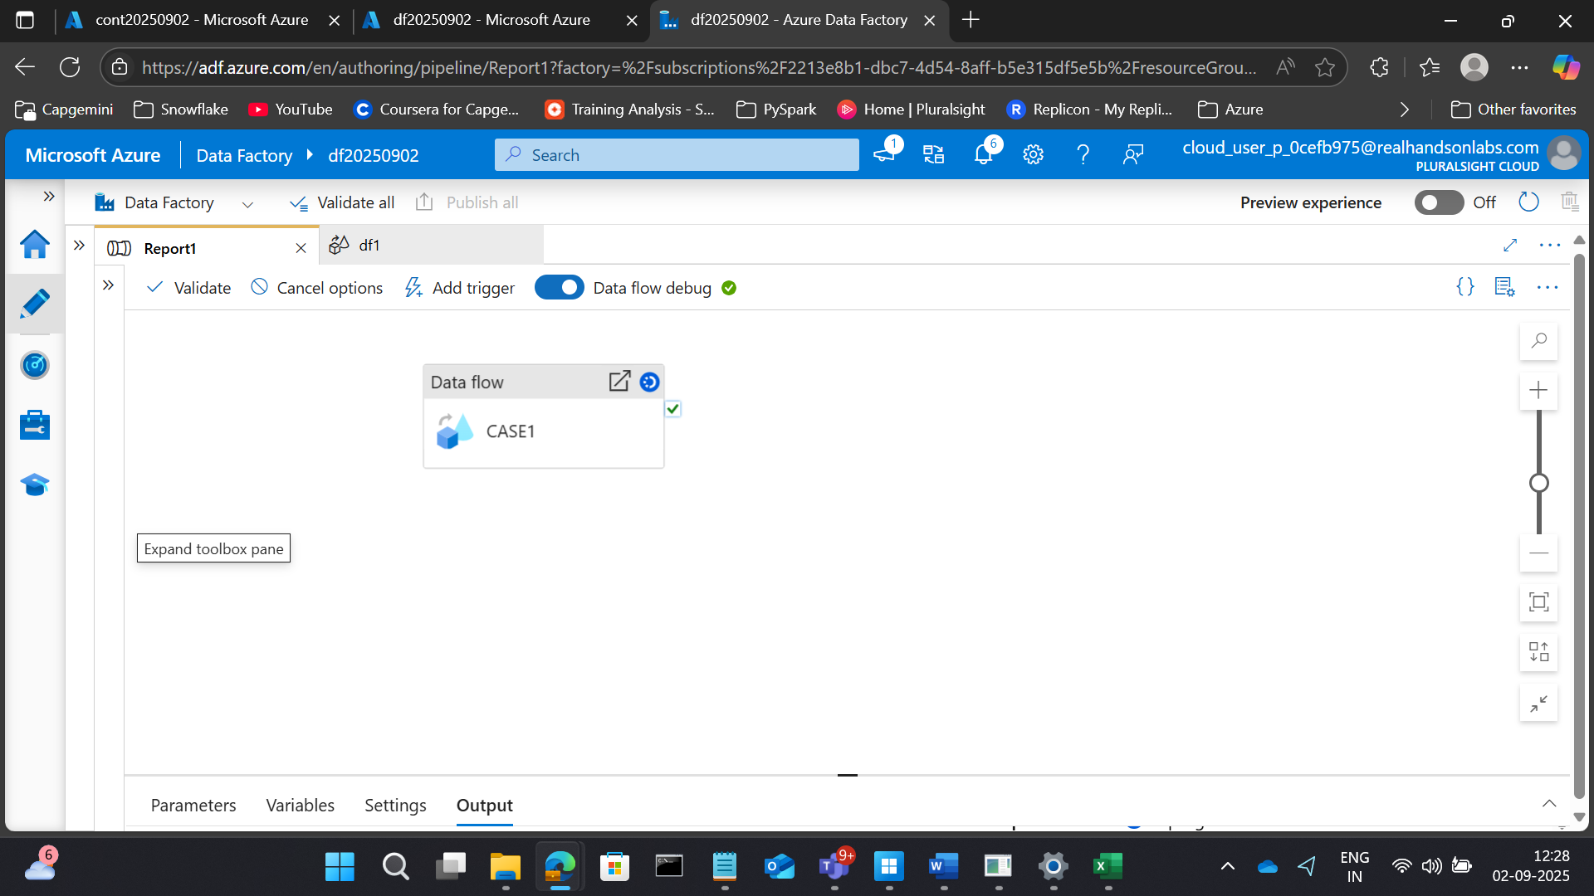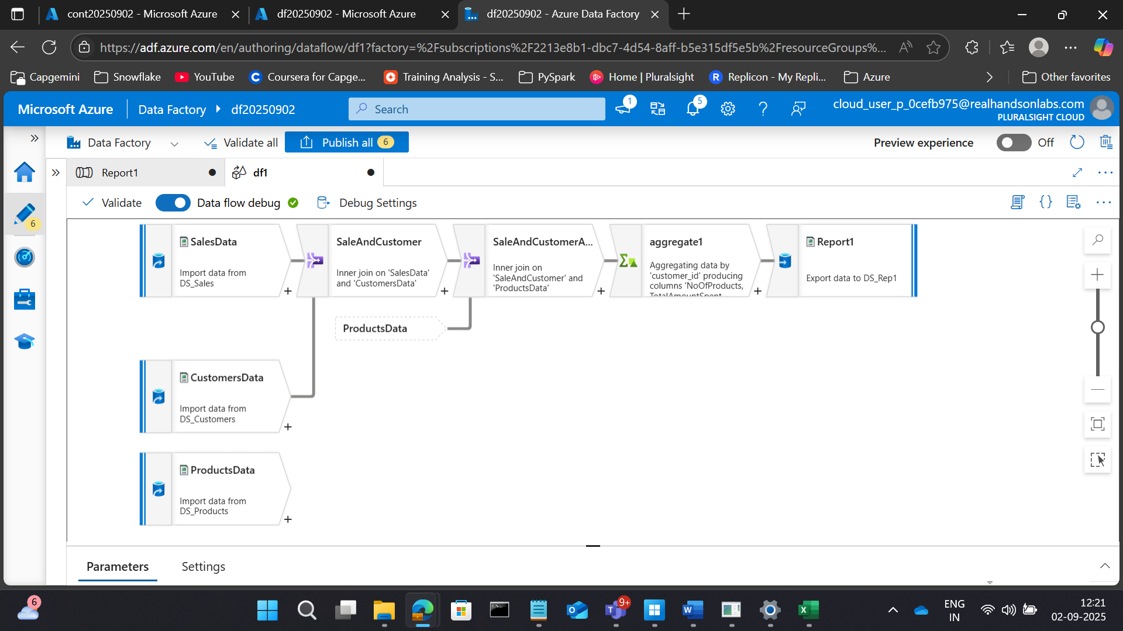

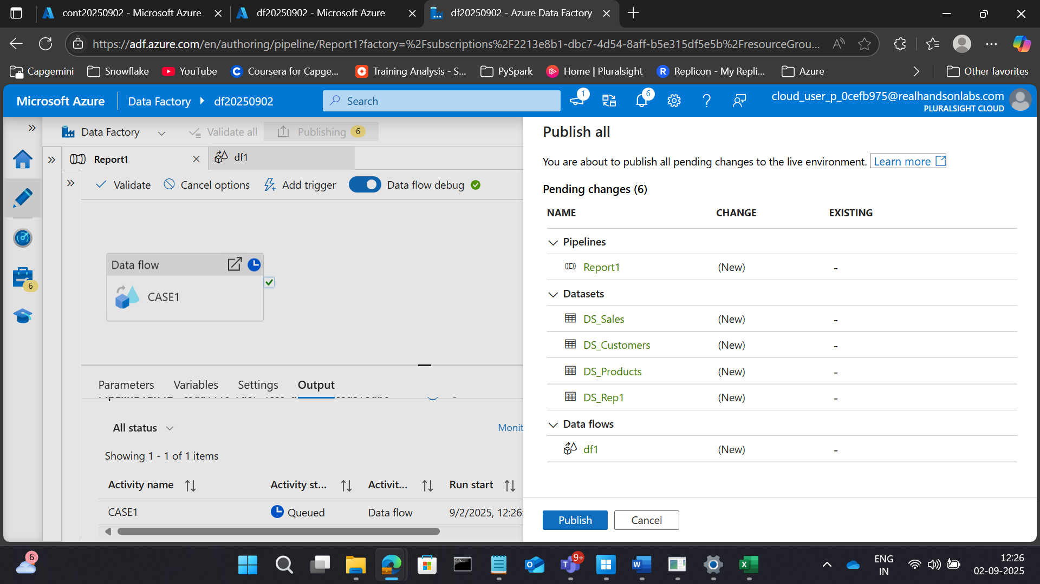

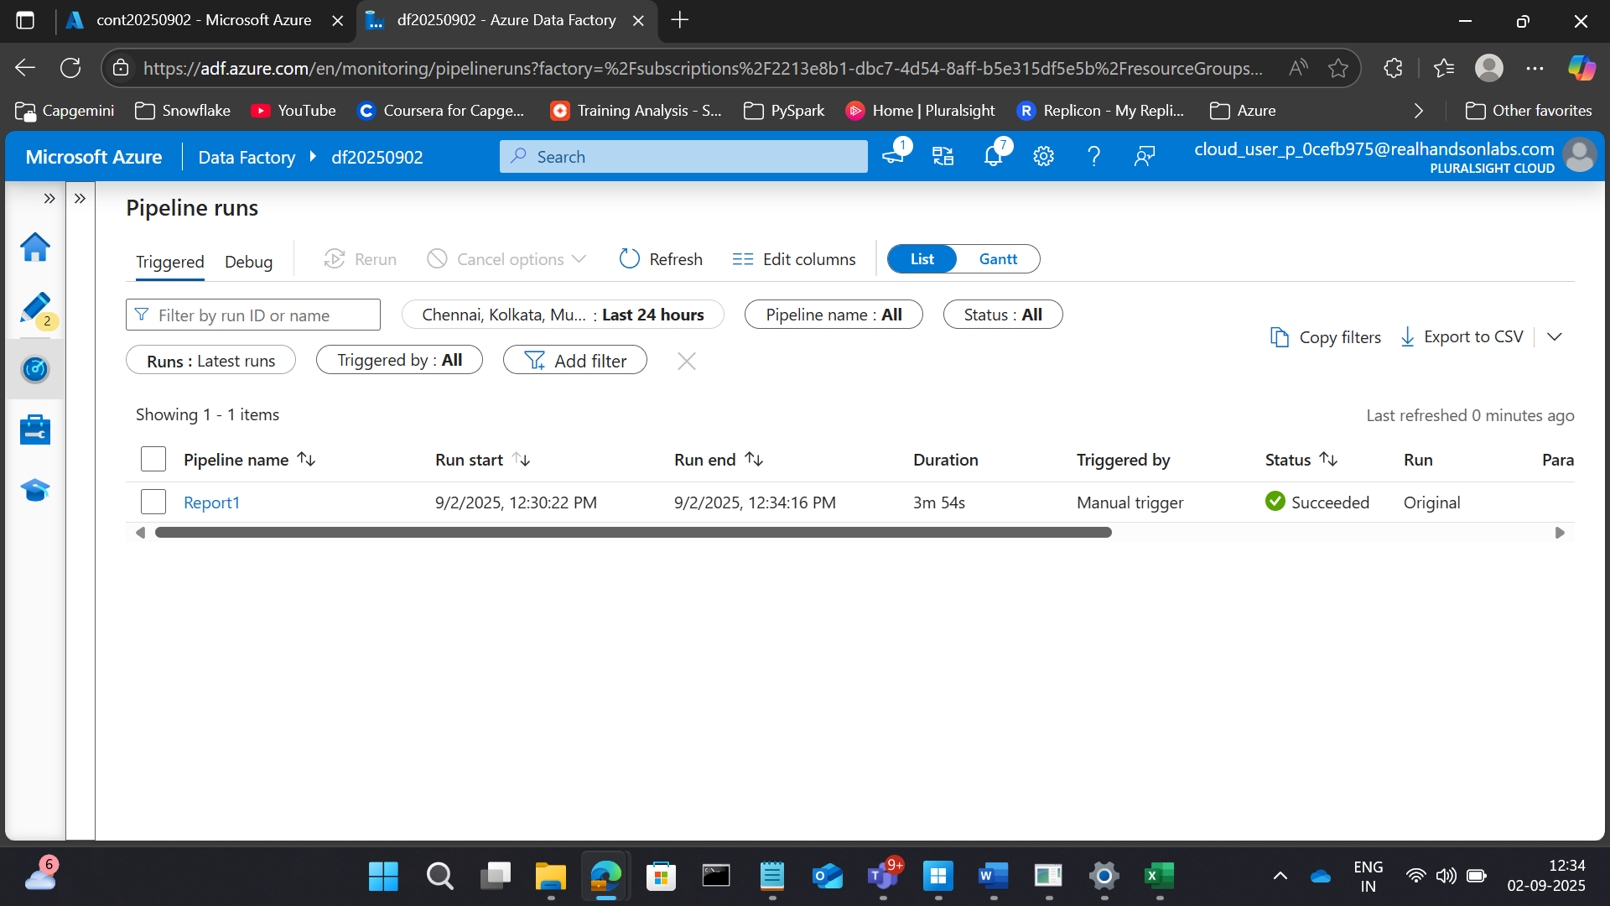

RESULT



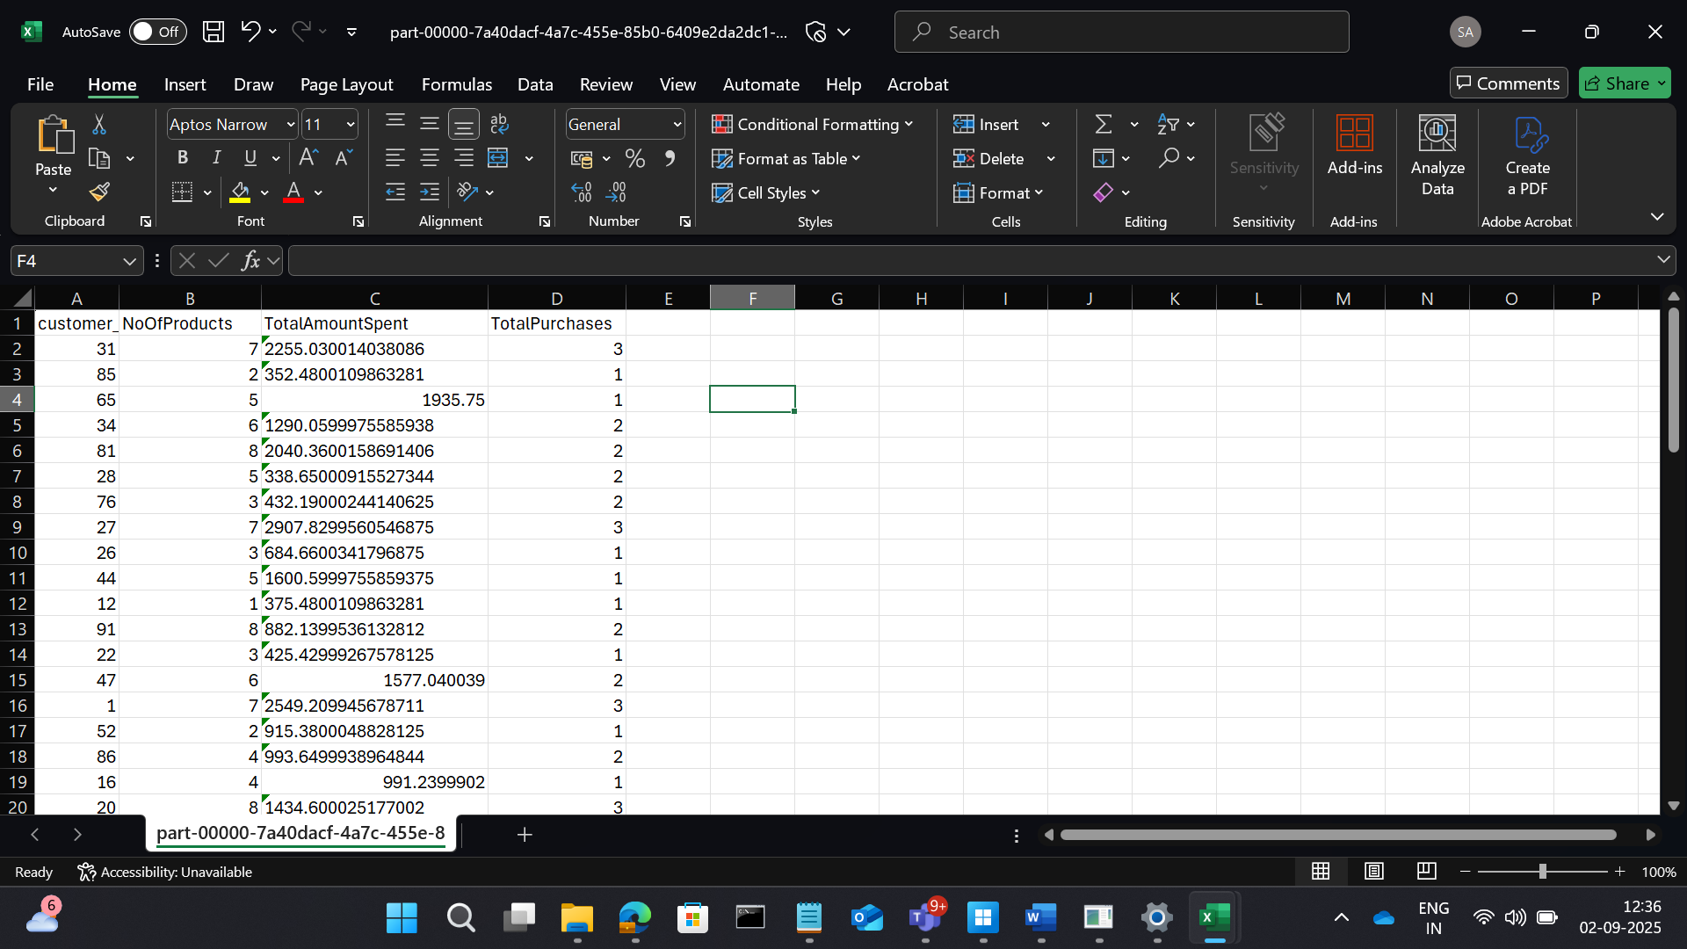

**2. Top-Selling Products**

**Goal:** Identify the top 5 products based on total sales revenue.

**Transformations:**

* Join sales.csv with products.csv.
* Calculate revenue = quantity × price.
* Group by product_id, then sort by revenue.

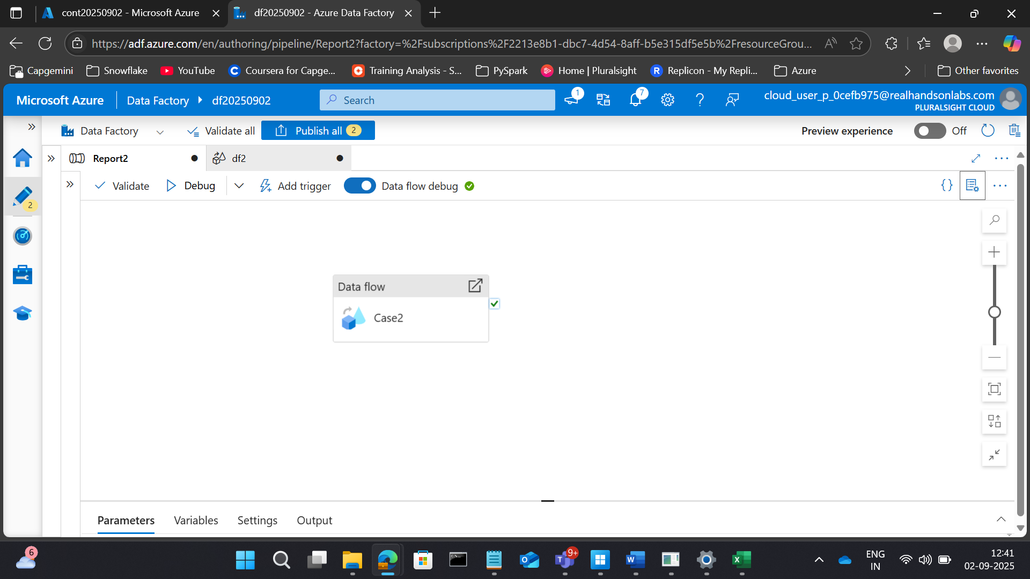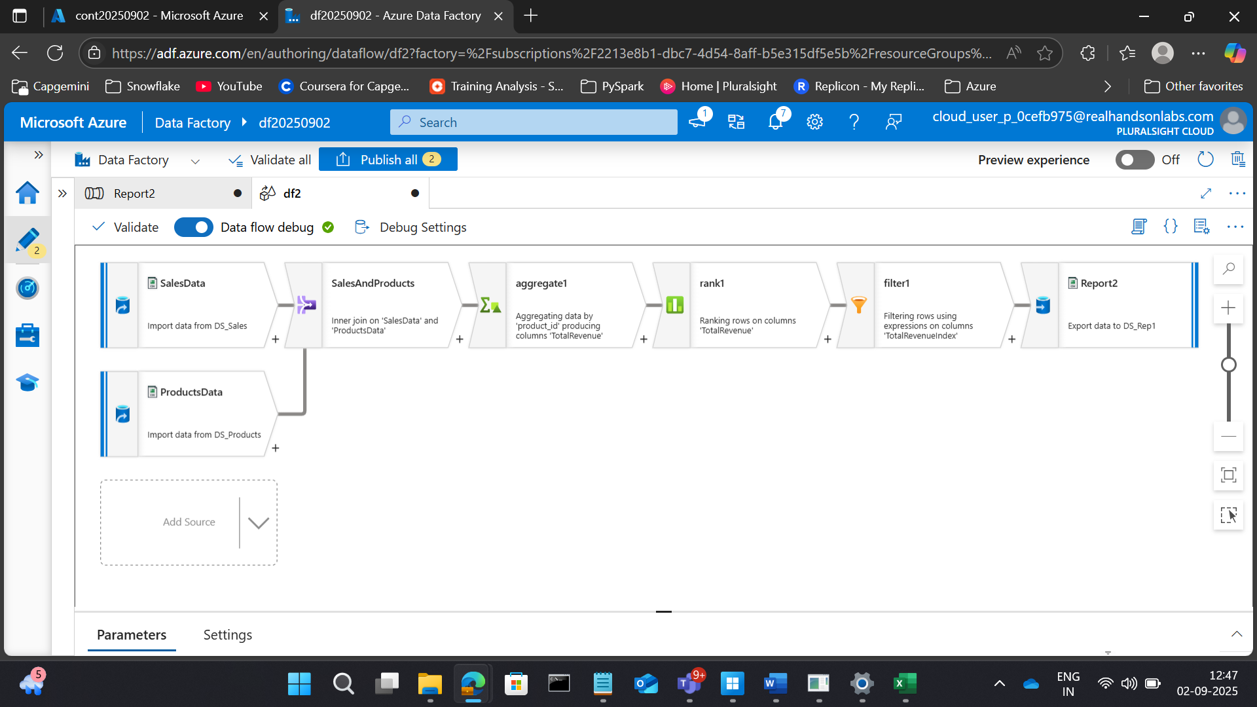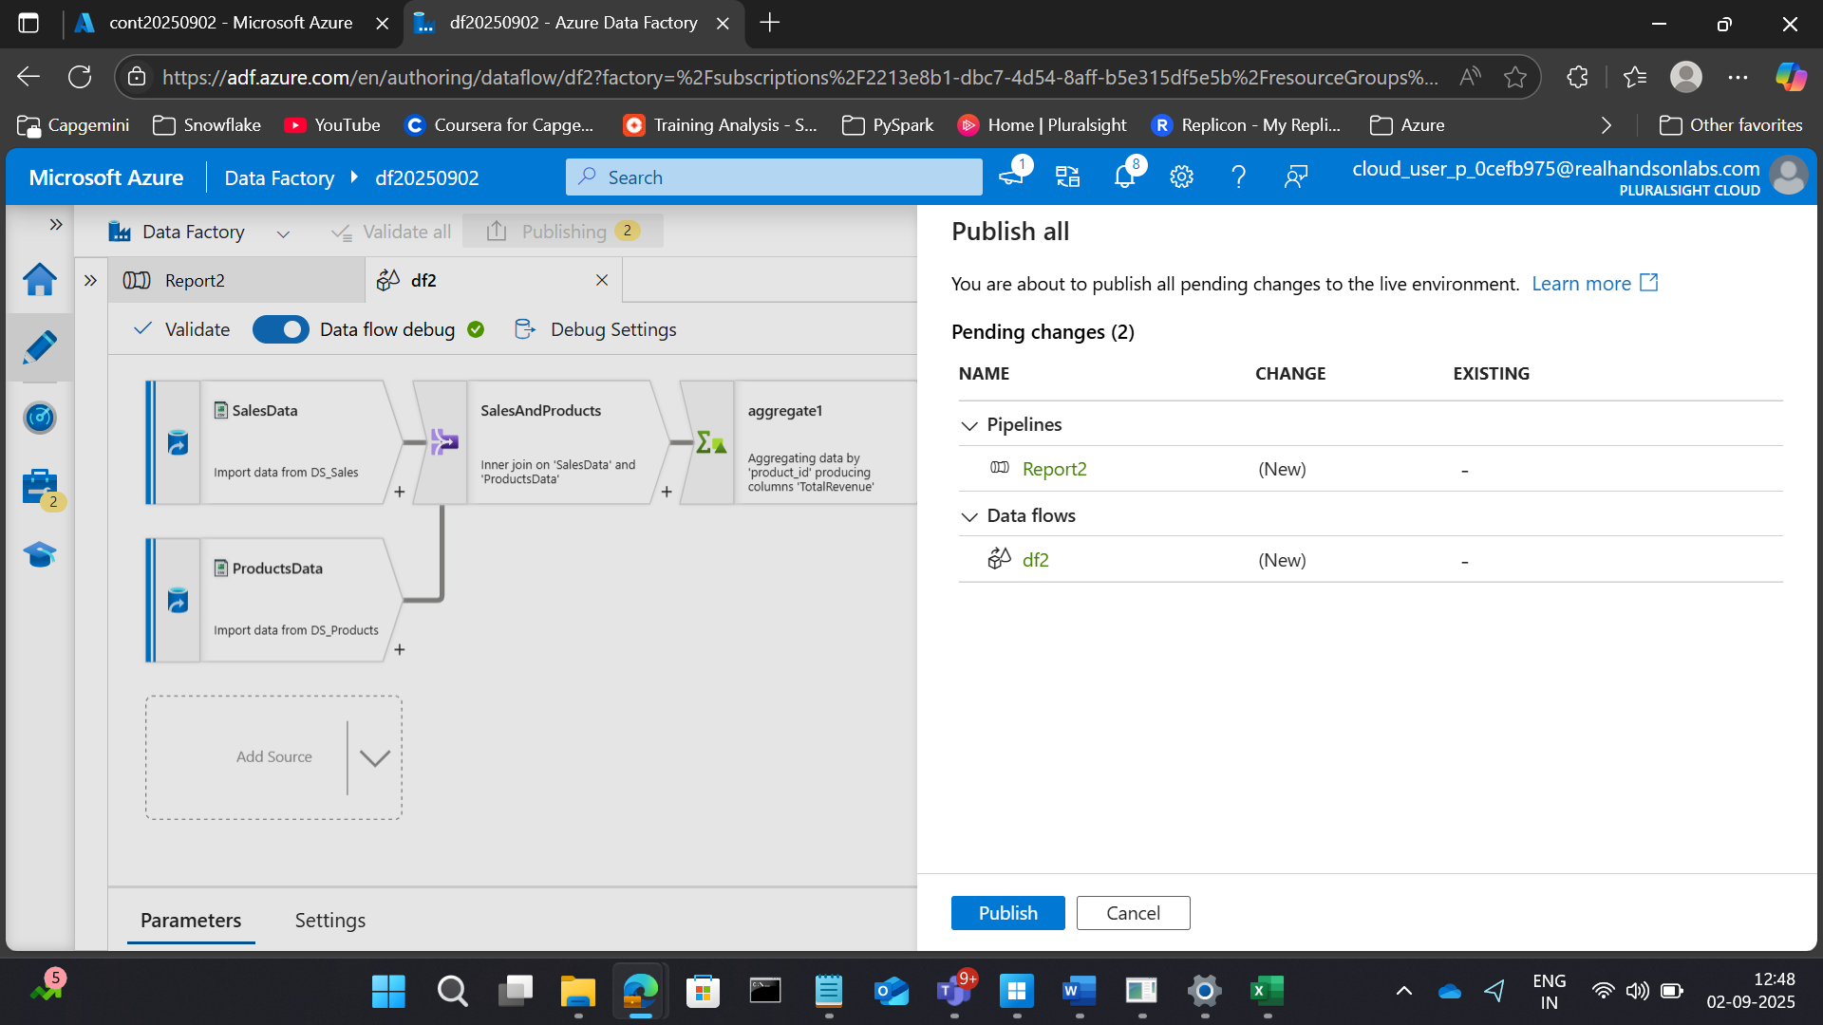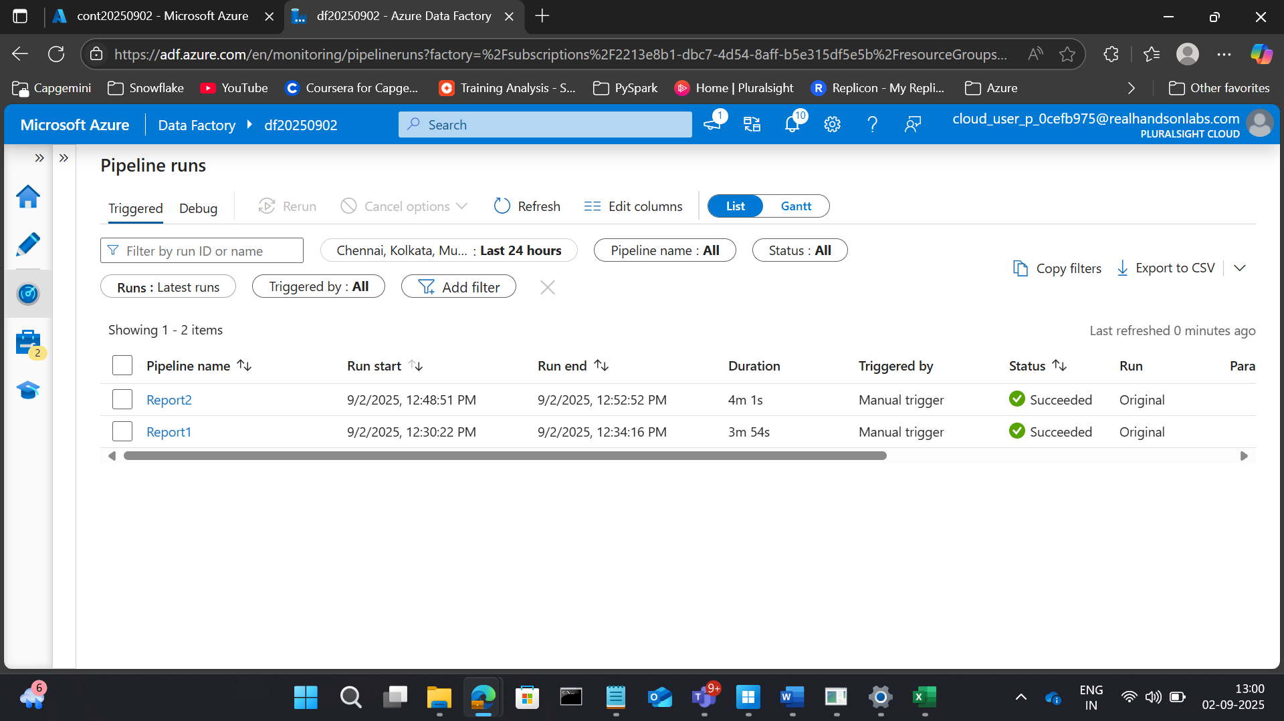RESULT

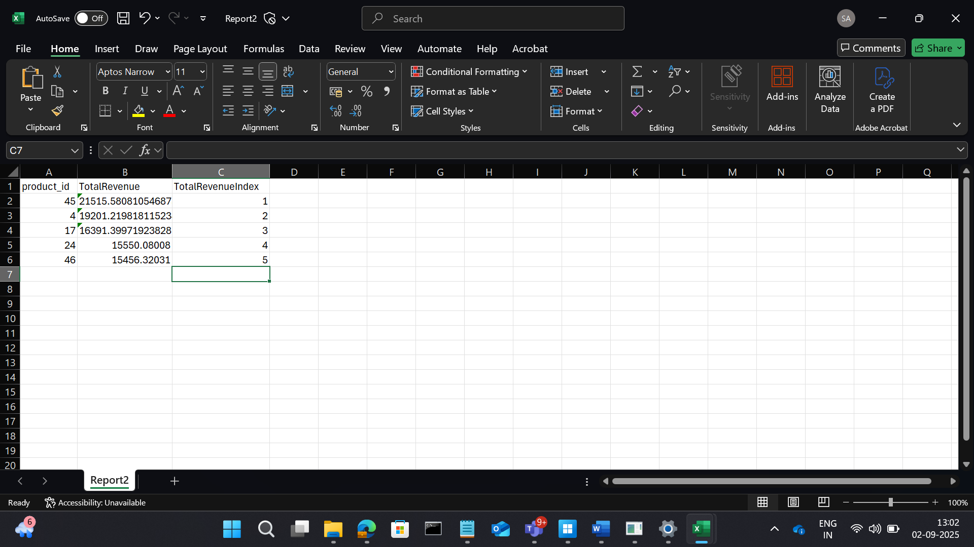

**3. Sales Trend Over Time**

**Goal:** Analyze monthly sales trends to identify peak periods.

**Transformations:**

* Extract month and year from sale_date.
* Group by month-year.
* Aggregate total sales and revenue.

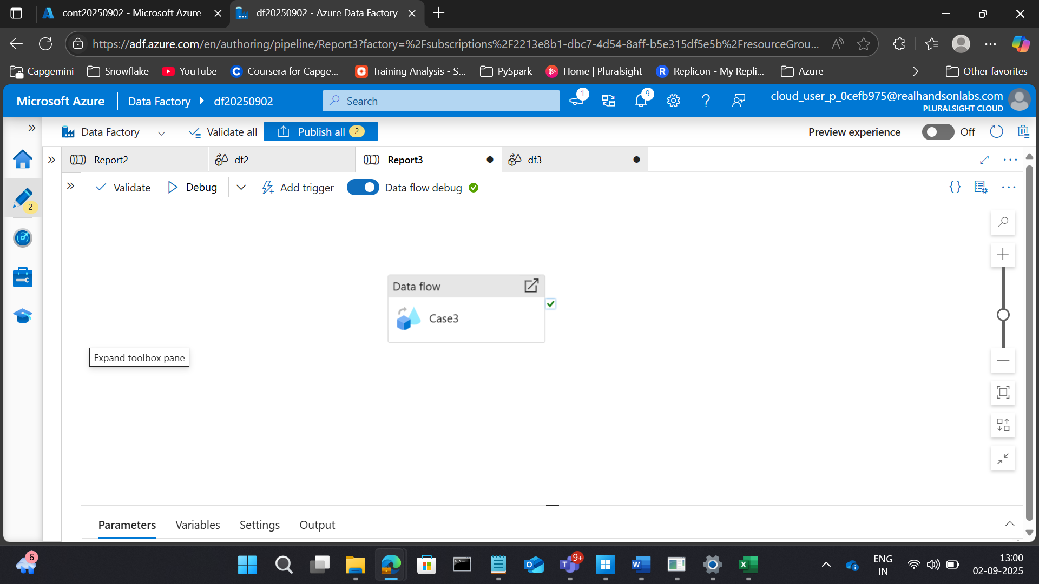

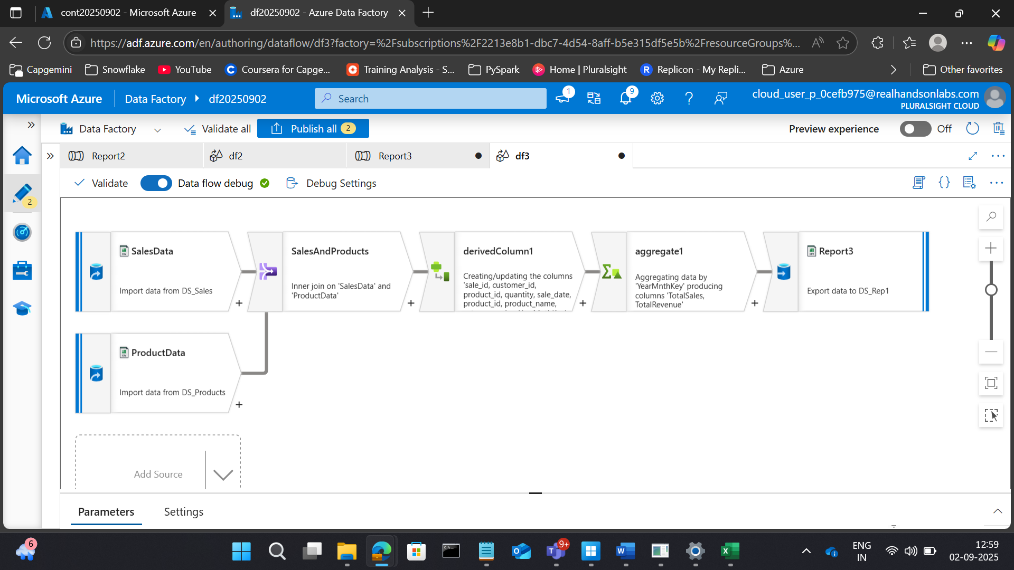

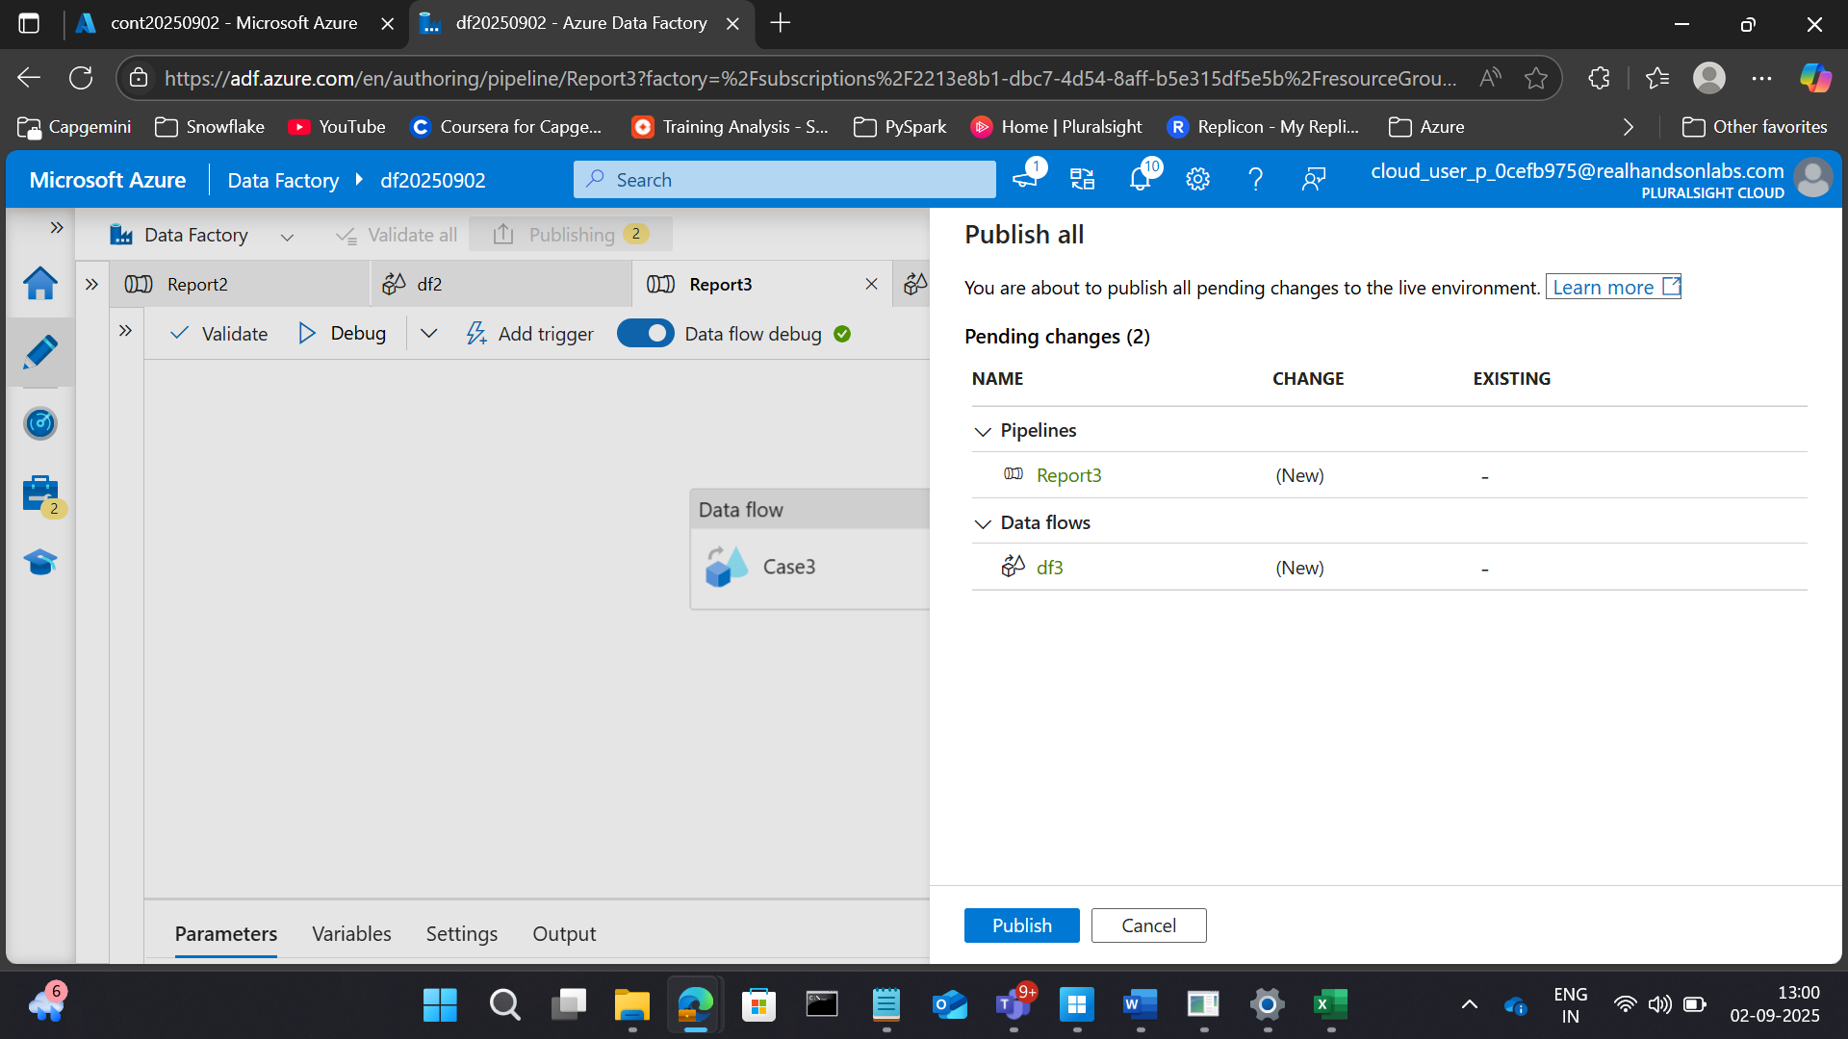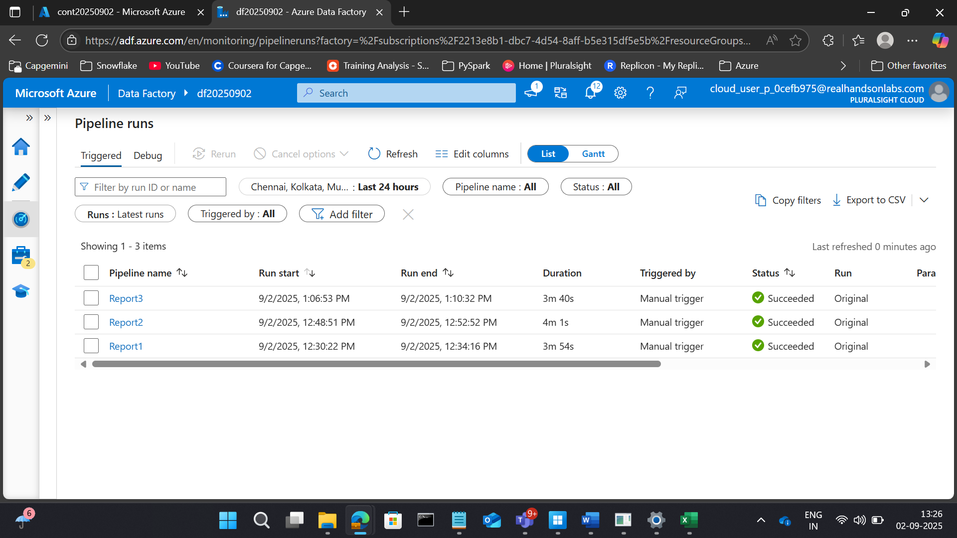

RESULTS

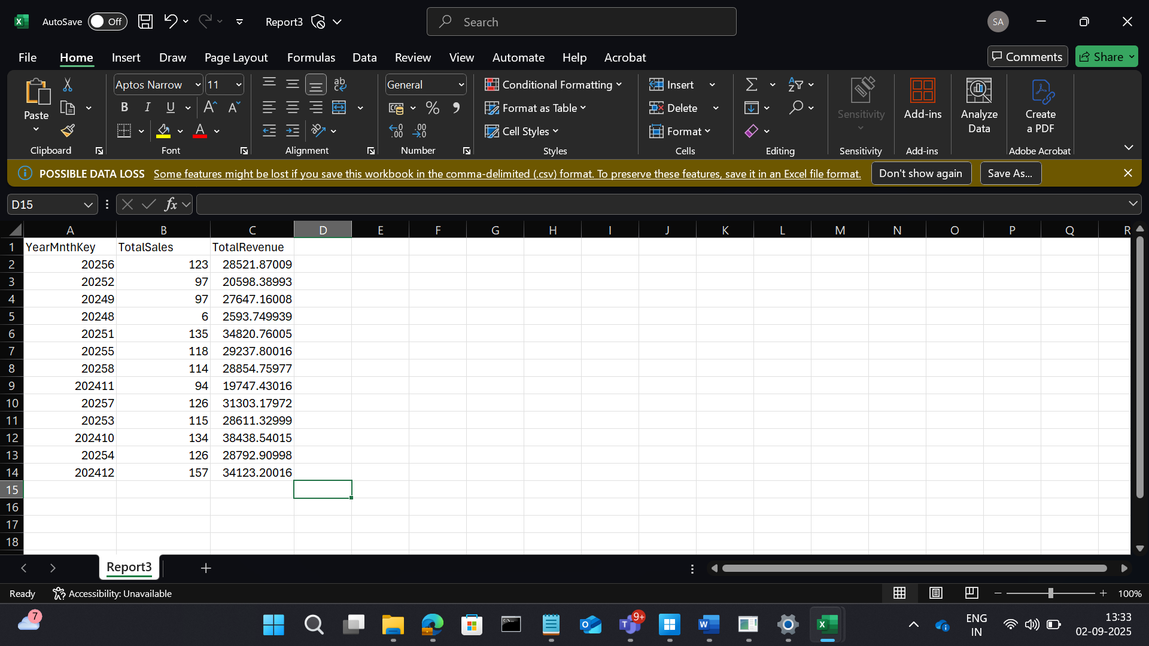

**4. Customer Segmentation by Location**

**Goal:** Segment customers based on location and analyze their buying behavior.

**Transformations:**

* Join sales.csv with customers.csv.
* Group by location.
* Aggregate total quantity and revenue.

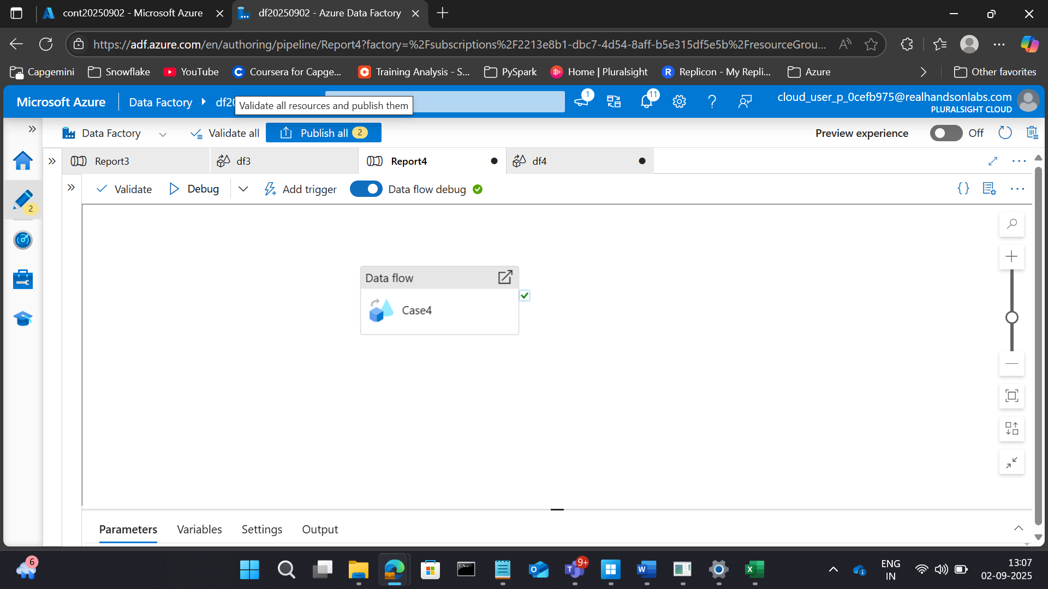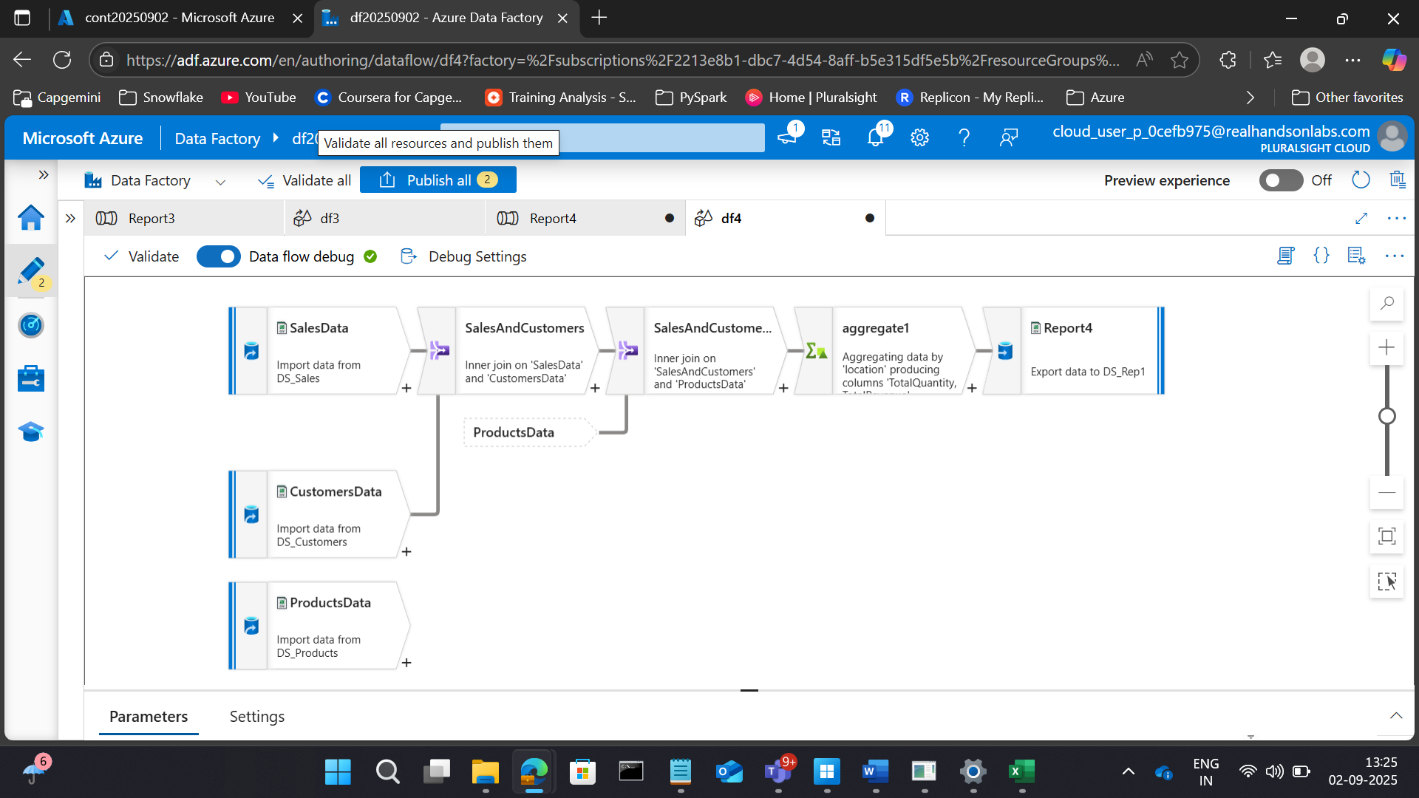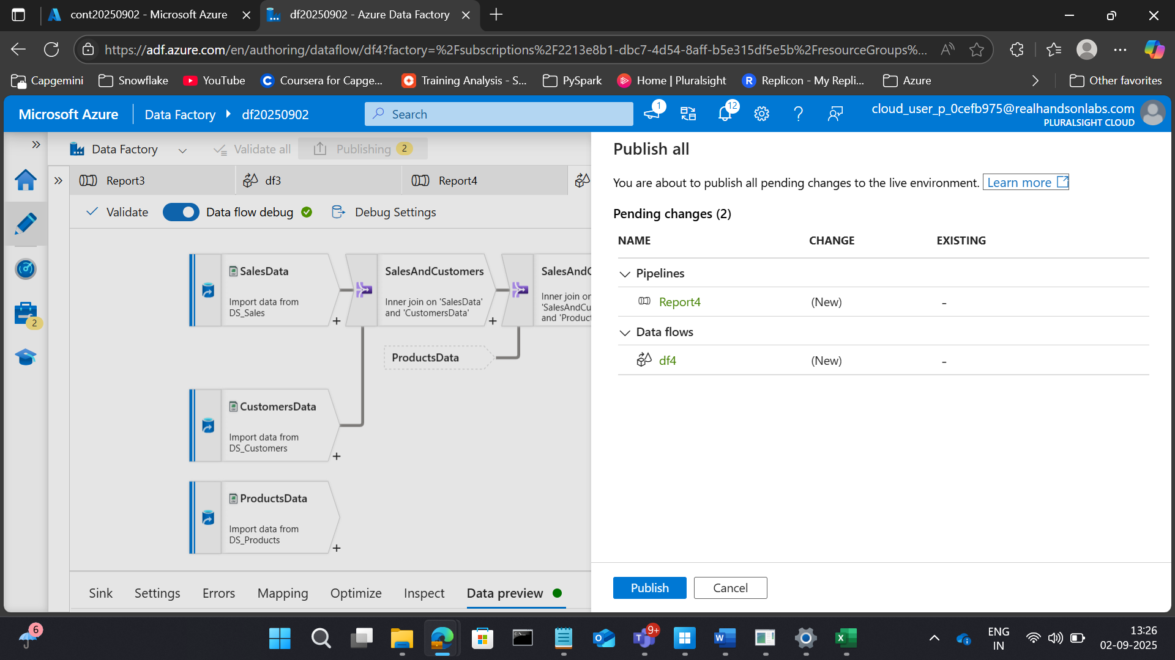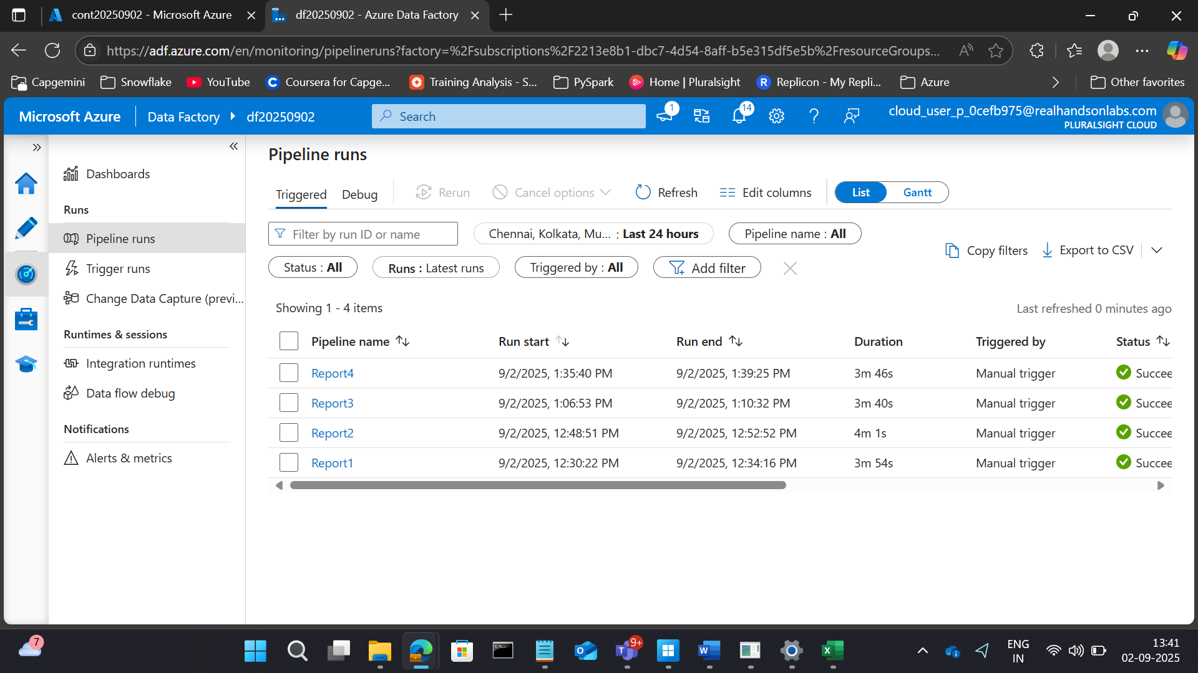

RESULTS

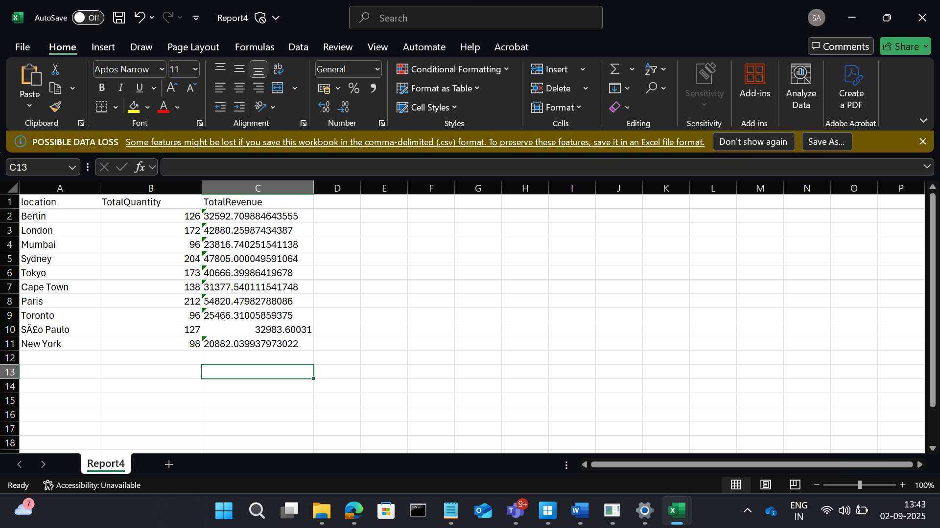

**5. Product Category Performance**

**Goal:** Evaluate which product categories generate the most revenue.

**Transformations:**

* Join sales.csv with products.csv.
* Group by category.
* Sum revenue.

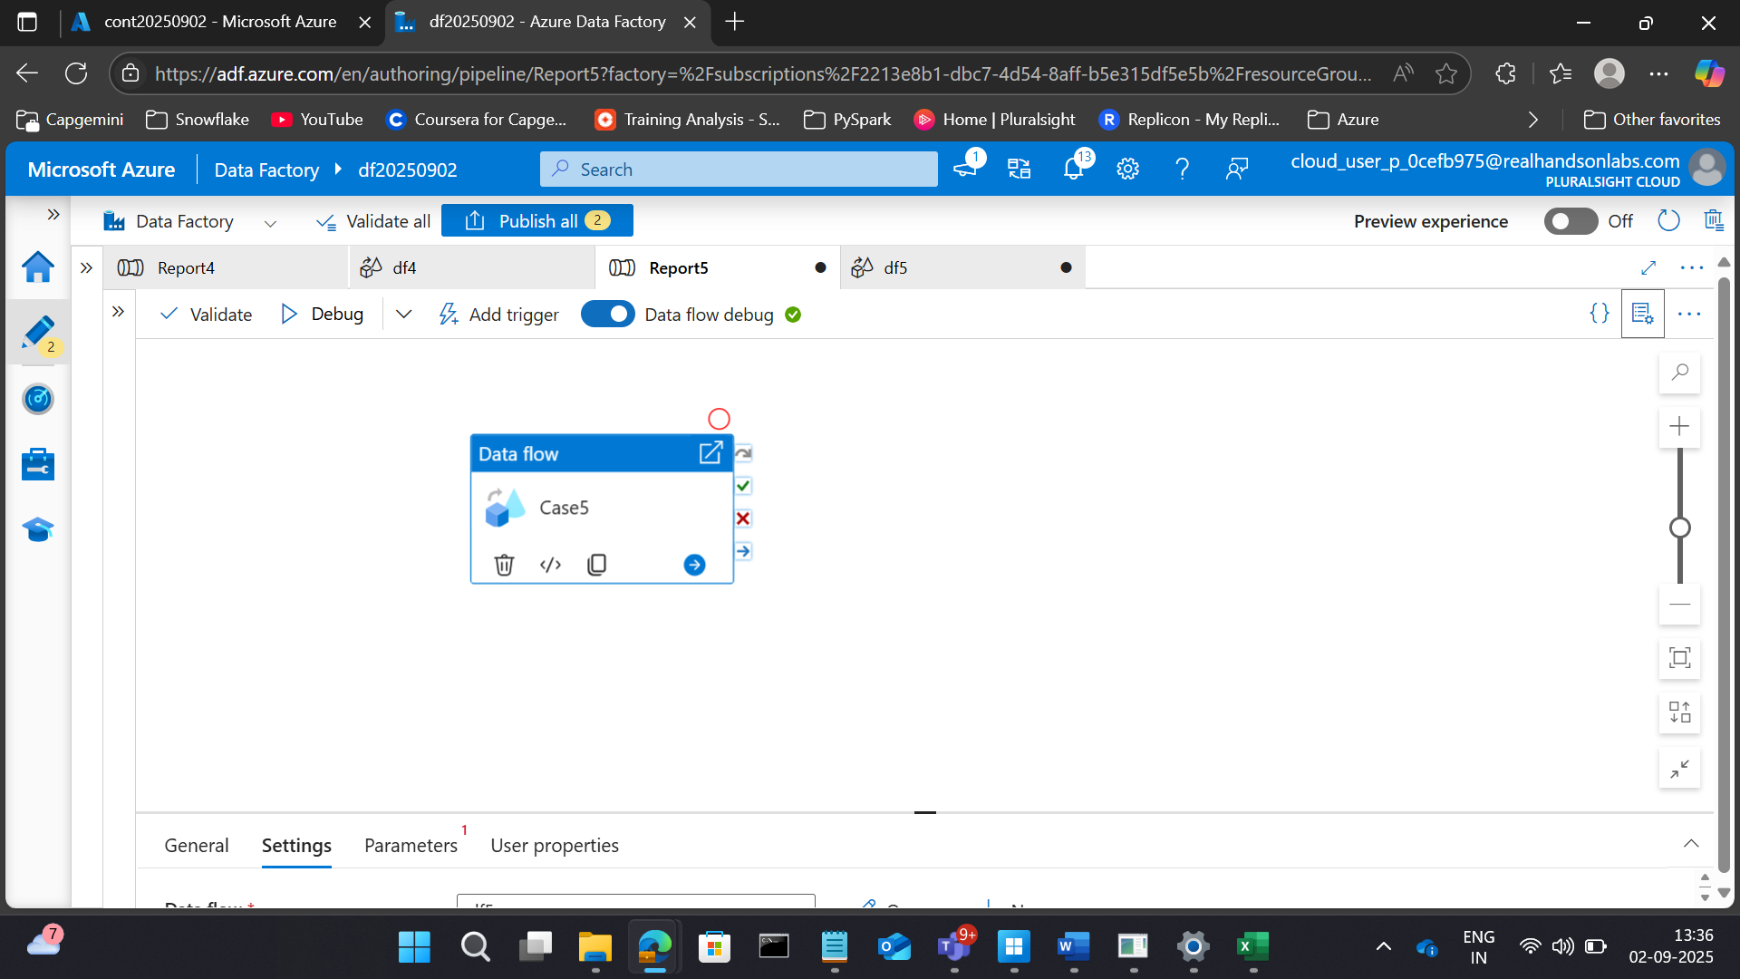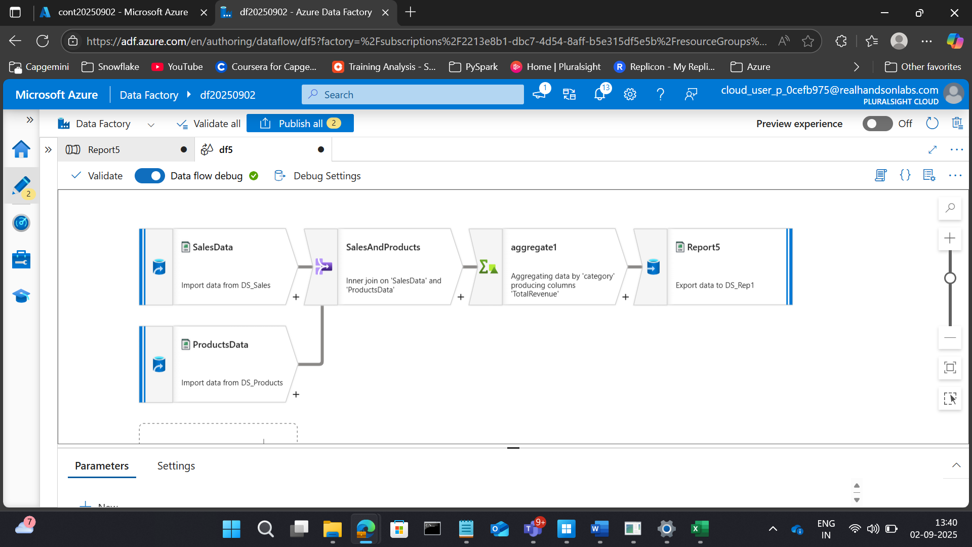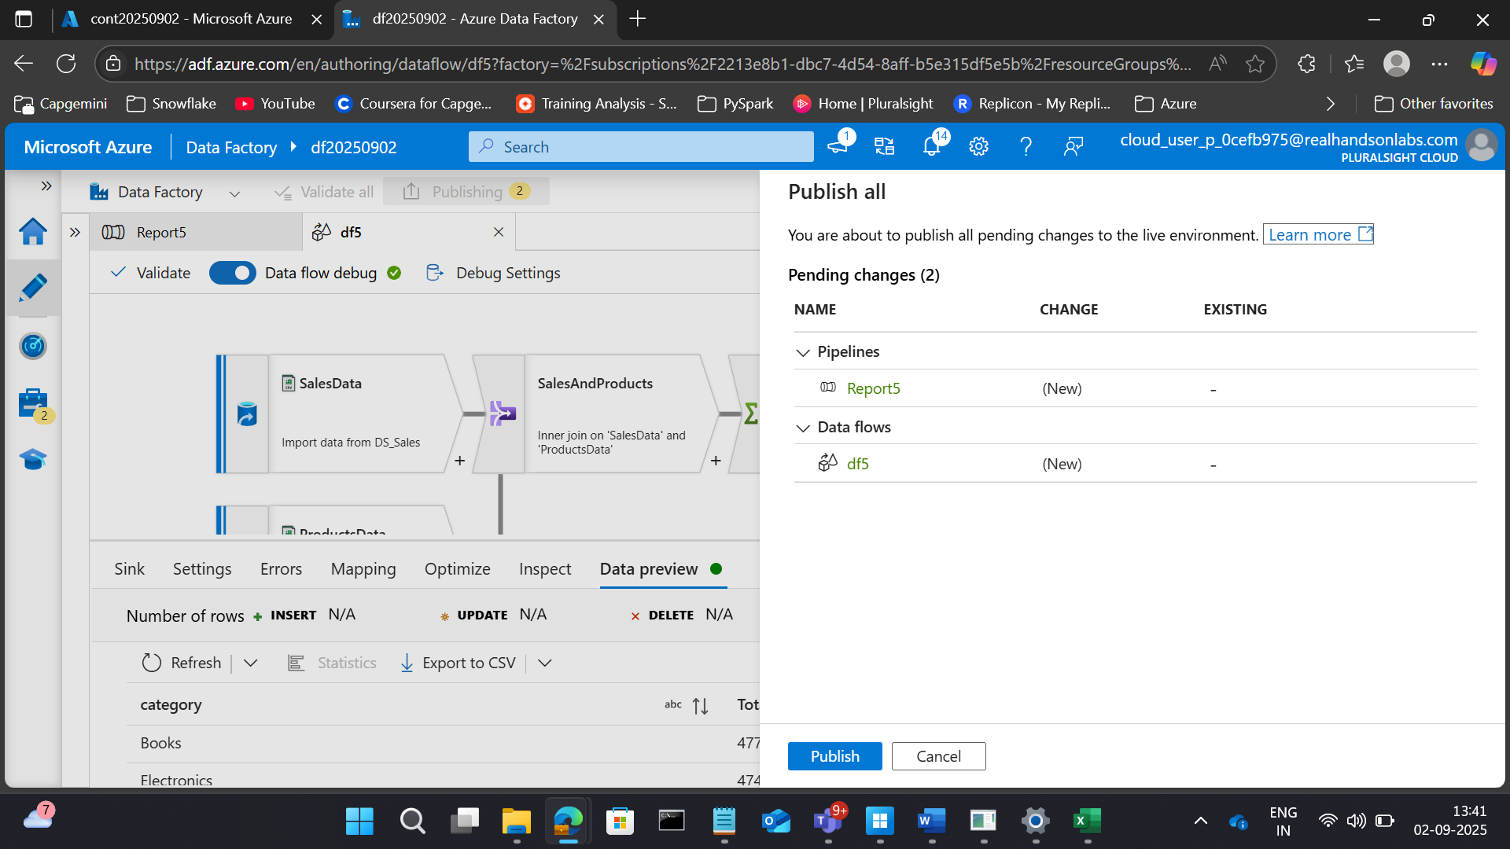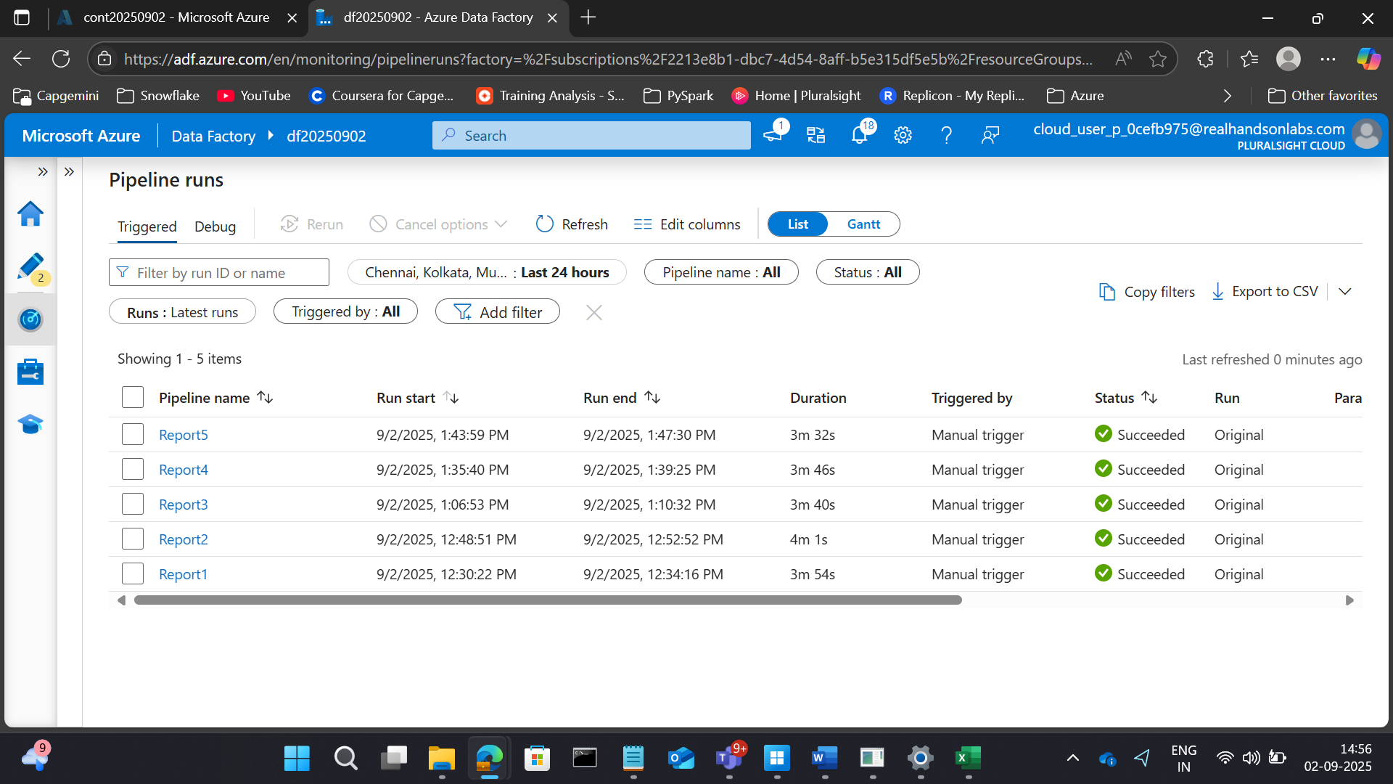

REPORTS

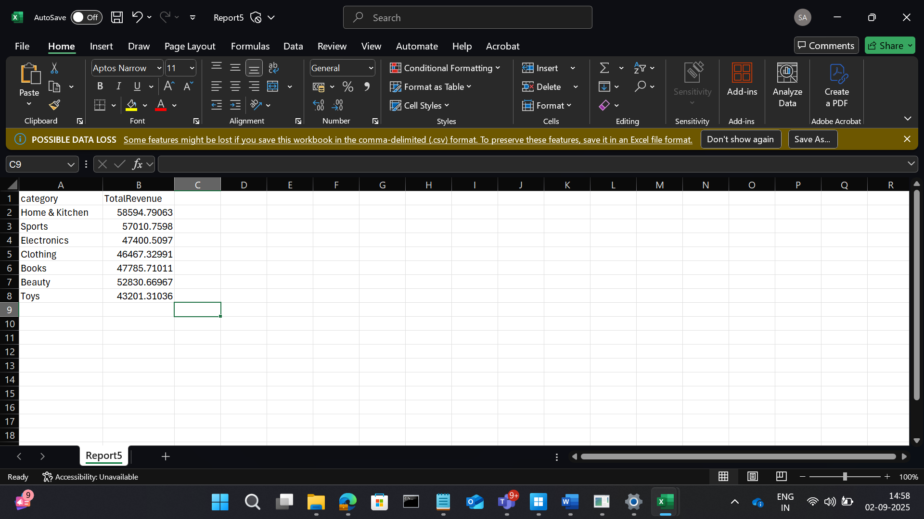

**6. Inactive Customers**

**Goal:** Identify customers who haven’t made any purchases in the last 6 months.

**Transformations:**

* Filter sales.csv for recent dates.
* Compare with full customer list.
* Identify customers not in recent sales.

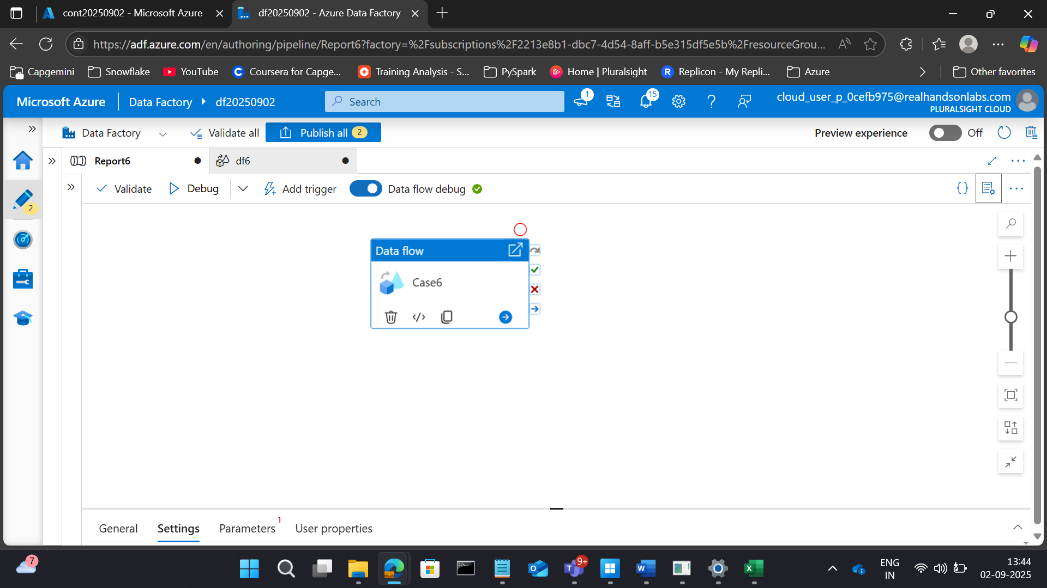

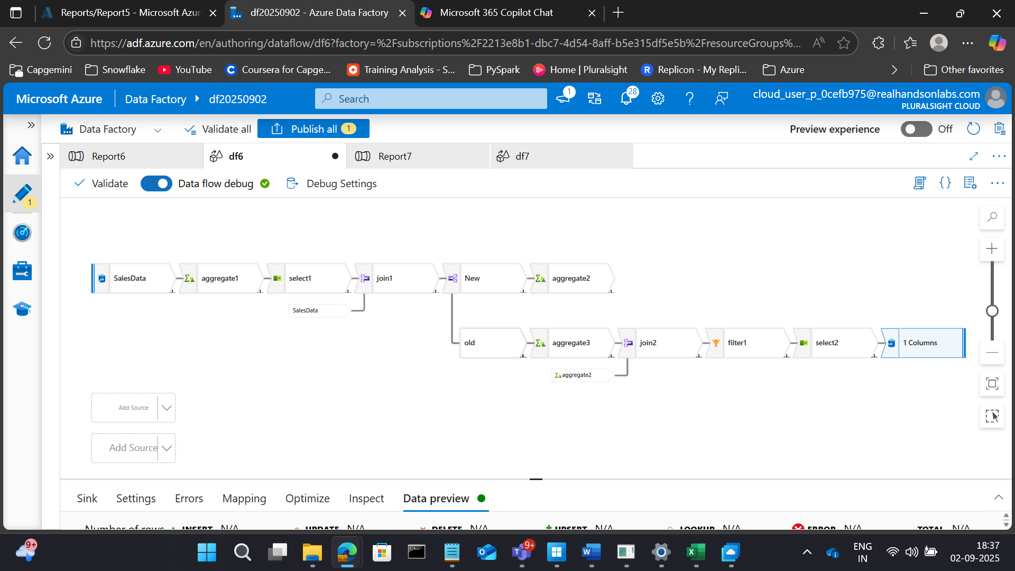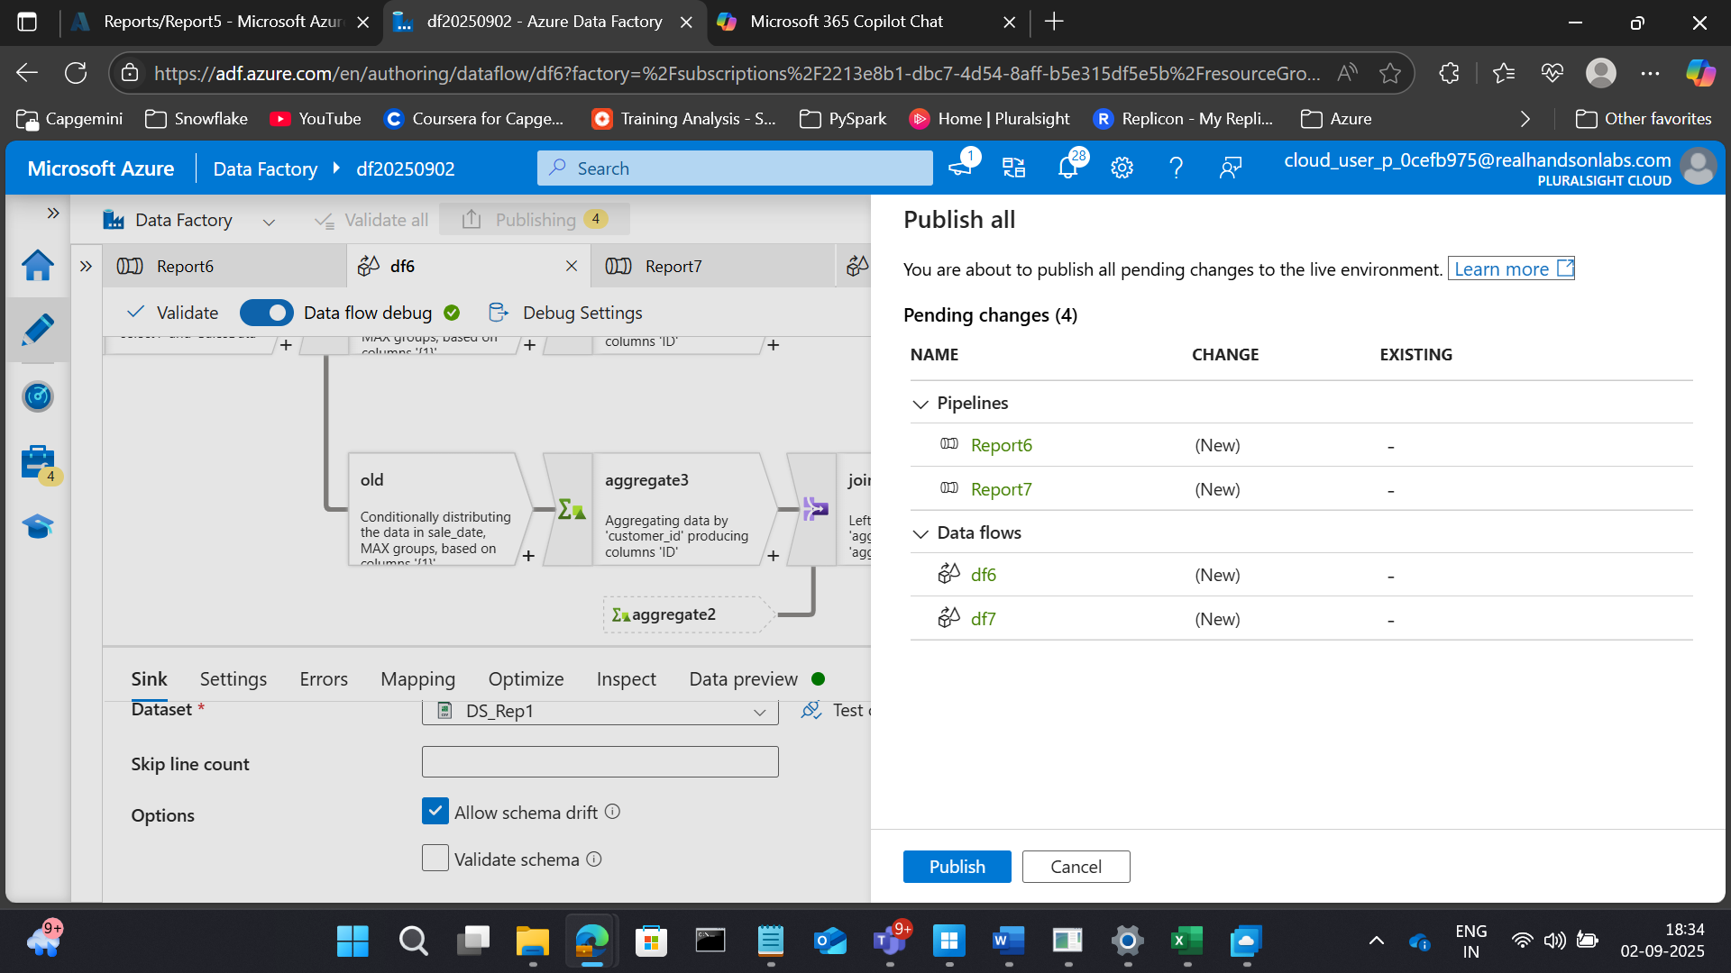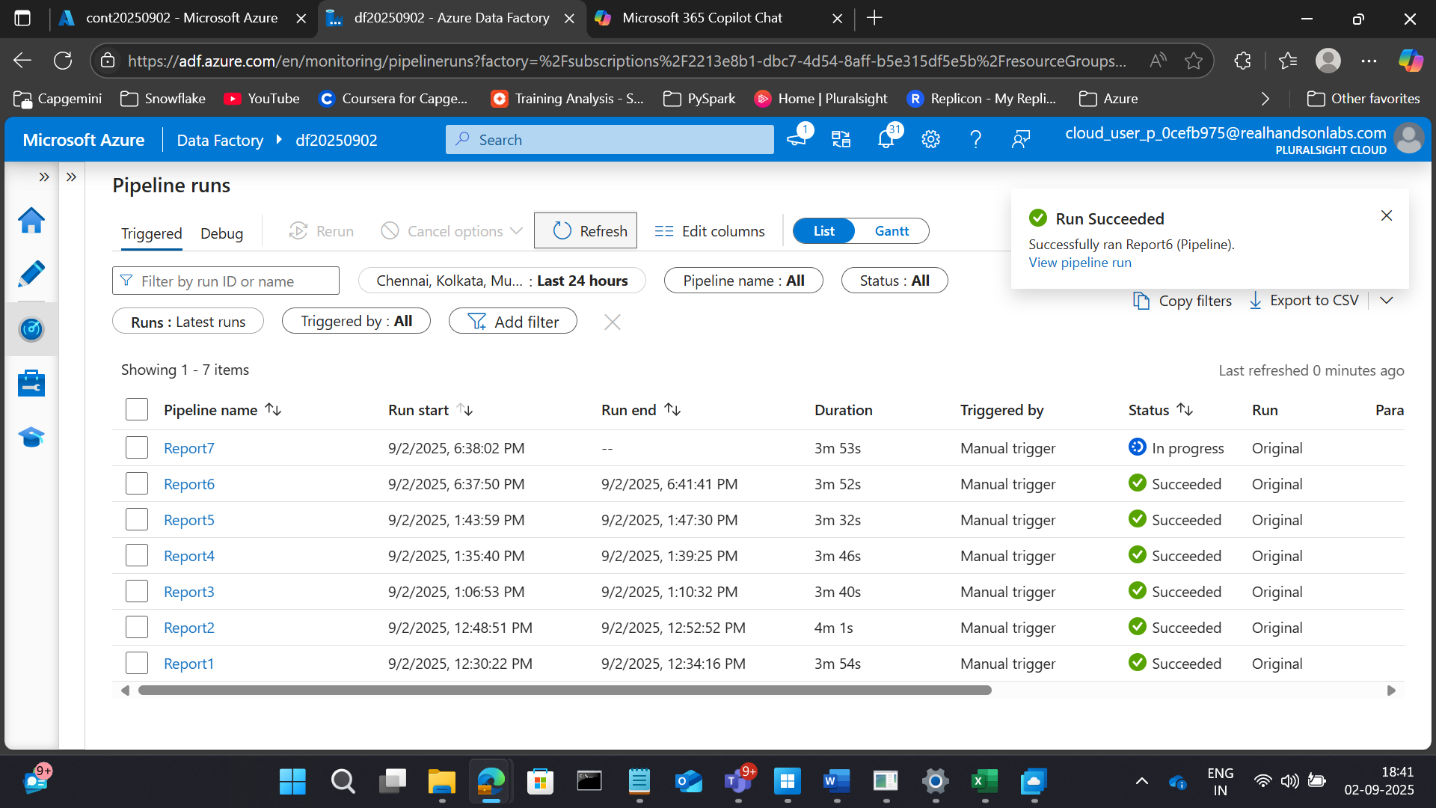

RESULTS

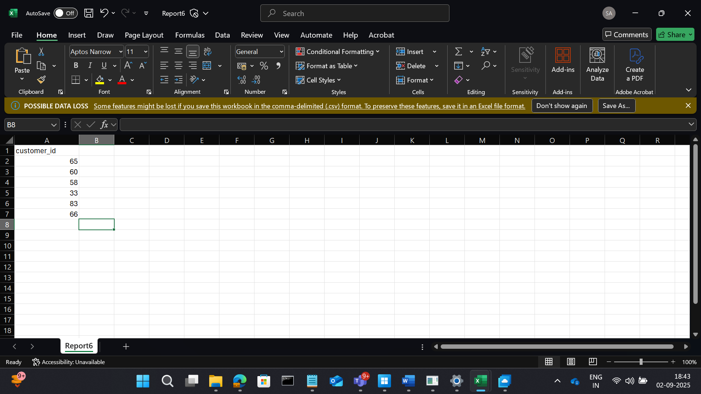

**7. Average Order Value (AOV)**

**Goal:** Calculate the average order value per customer.

**Transformations:**

* Join all datasets.
* Group by customer_id.
* Compute total_revenue / total_orders.

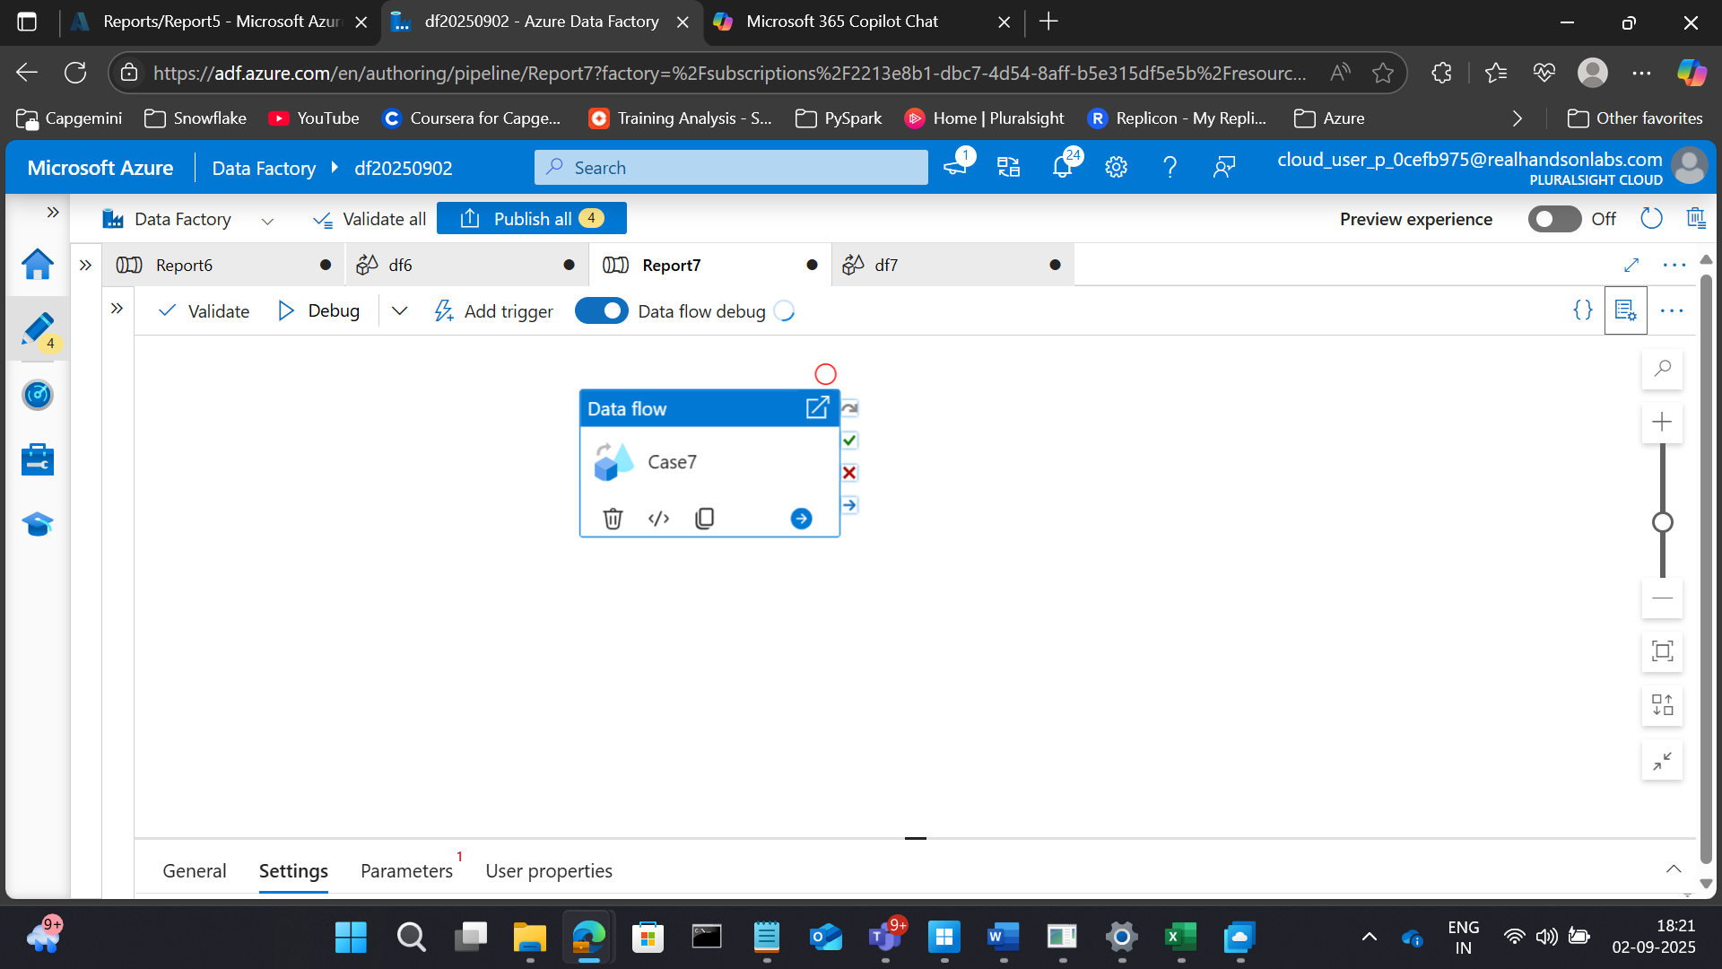

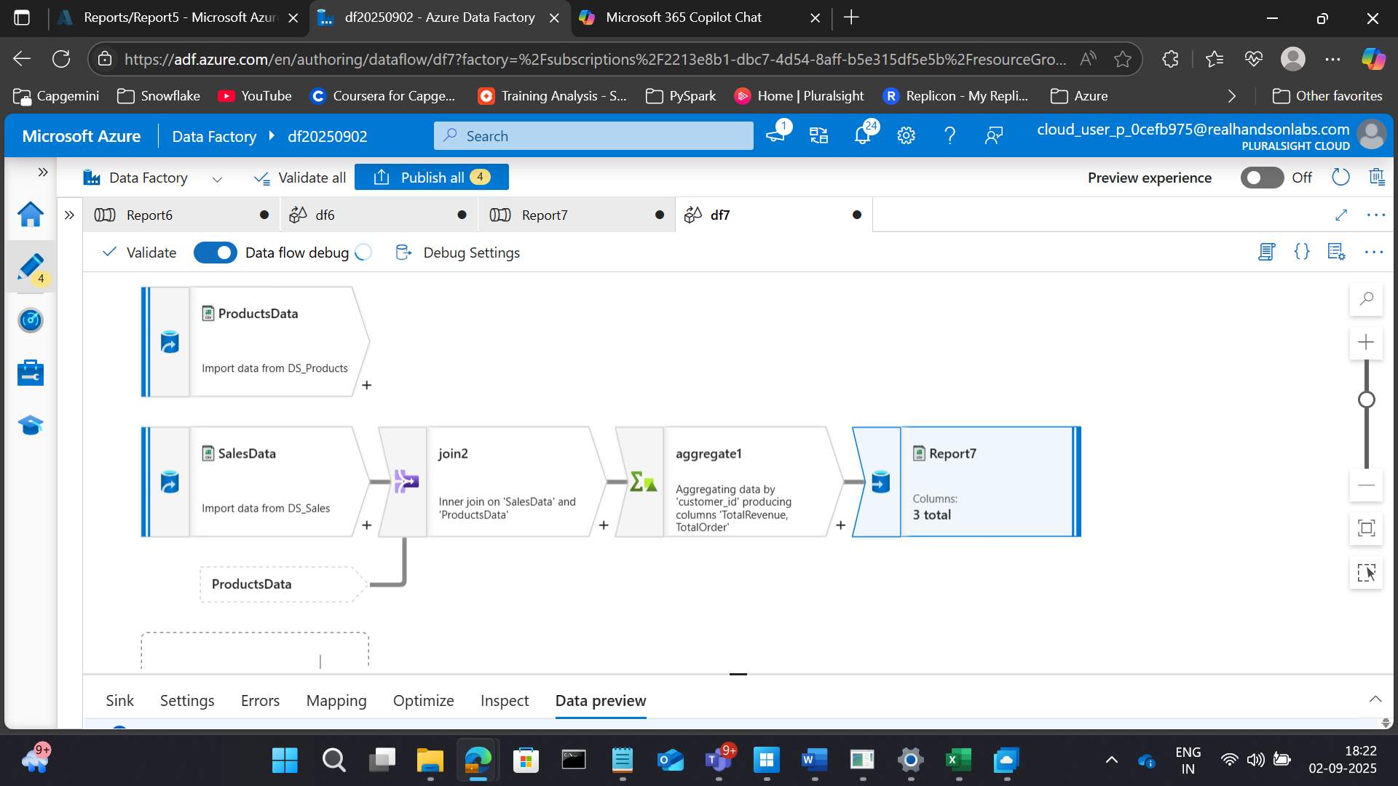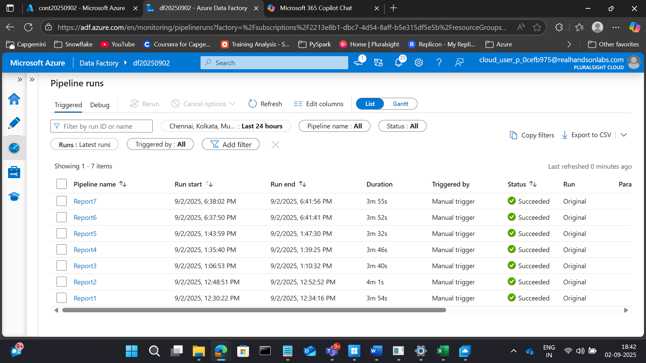

RESULTS

